**Wire-Frame Design**

**BIG MART SALES PREDICTION**

|  |  |
| --- | --- |
| Written By | Anubhav Tewari |
| Document Version | 1.0 |
| Last Revised Date | 28-09-2021 |

**Document Change Control Record**

|  |  |  |  |
| --- | --- | --- | --- |
| **Version** | **Date** | **Author** | **Comments** |
|  |  |  |  |
|  |  |  |  |
|  |  |  |  |
|  |  |  |  |
|  |  |  |  |
|  |  |  |  |
|  |  |  |  |
|  |  |  |  |
|  |  |  |  |
|  |  |  |  |
|  |  |  |  |
|  |  |  |  |
|  |  |  |  |
|  |  |  |  |
|  |  |  |  |
|  |  |  |  |

**Reviews**

|  |  |  |  |
| --- | --- | --- | --- |
| **Version** | **Date** | **Reviewer** | **Comments** |
|  |  |  |  |

### **Approval Status:**

|  |  |  |  |  |
| --- | --- | --- | --- | --- |
| **Version** | **Review date** | **Reviewed By** | **Approved By** | **Comments** |
|  |  |  |  |  |

**Homepage**

On the homepage the user will be able to see the heading of the project name and there will be icon of GitHub and LinkedIn to connect to the developer, there will be 9 textboxes to give input about the product , that needs to be analyzed and its sales need to be predicted.

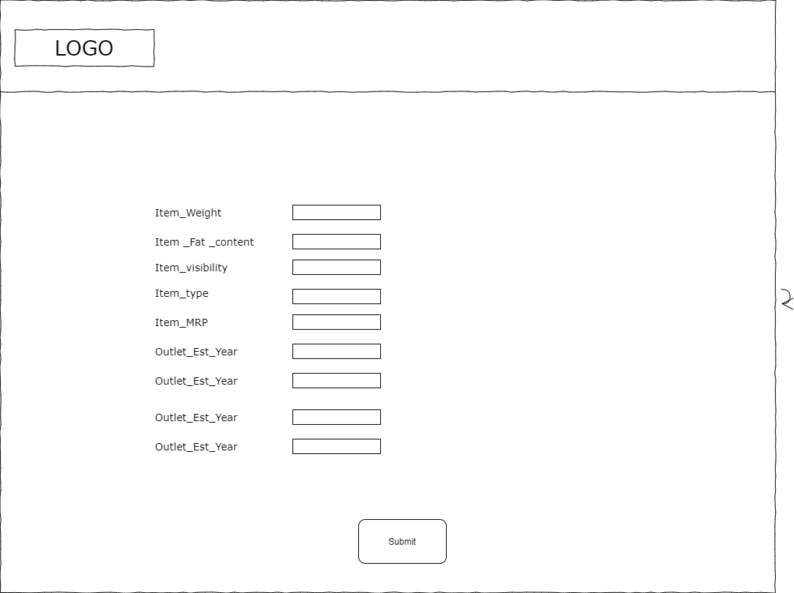

**Prediction Page**

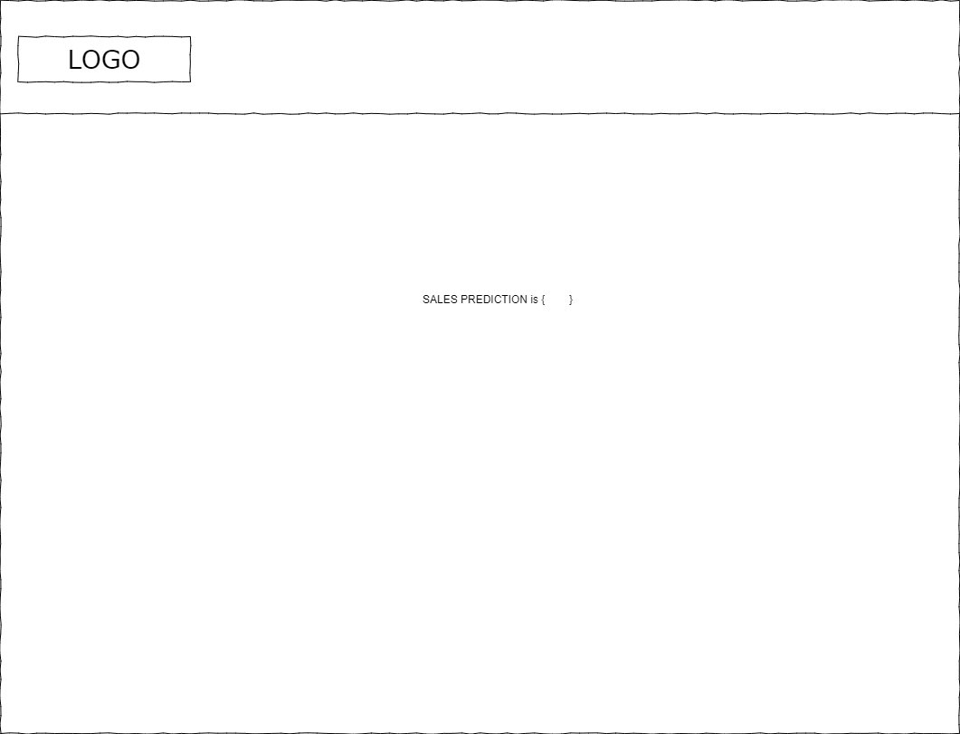

After the user will give inputs there will be predict button, on clicking predict button the next page will open which will be the result page where the prediction will be shown for the given inputs. The interface is quite simple since the web app is only performing 1 prediction a time. A text stating the product sales is projected.